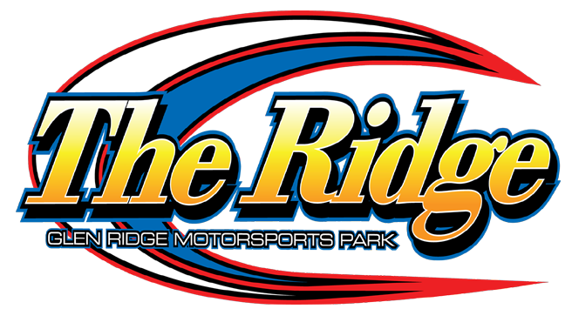

2024 358 MODIFIED SPECS

The 358 Modified division at The Ridge will follow the 2024 DIRTcar rule book with the following exceptions:

1). Fuel – VP Race Fuels is the preferred fuel at the Glen Ridge Motorsports Park. Or Pump Fuel. No oxygenated fuel.

2) Tires – Hoosier Racing Tires

3) Fire Suppression Bottle – Not mandatory BUT highly recommended at The Ridge – no weight break for teams utilizing this option but will be mandatory for the Dirt Series races at Glen Ridge and all other DIRTcar racetracks.
*Rules Are Subject To Change*

