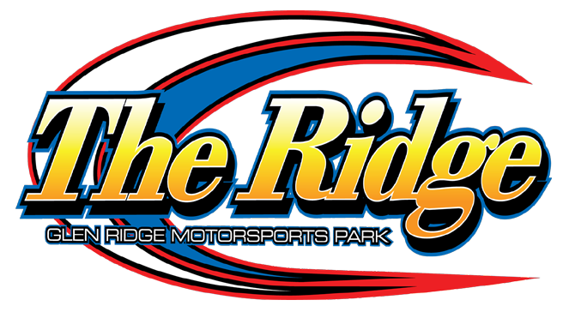

2024 602 CRATE SPORTSMAN SPECS

Rev. boxes are mandatory set at no more than 6000 RPM

The 602 Sportsman division at The Ridge will follow the 2024 DIRTcar rule book with the following exceptions:

- Weight – minimum 2,400 lbs., taken post-race, with driver, track scale pounds.

2). Fuel – VP Race Fuels is the preferred fuel at the Glen Ridge Motorsports Park. Or Pump Fuel. No oxygenated fuel.

3) Tires – Hoosier Racing Tires

4) Fire Suppression Bottle – Not mandatory BUT highly recommended at The Ridge – no weight break for teams utilizing this option but will be mandatory for the Dirt Series races at Glen Ridge and all other DIRTcar racetracks.
*Rules Are Subject To Change*

