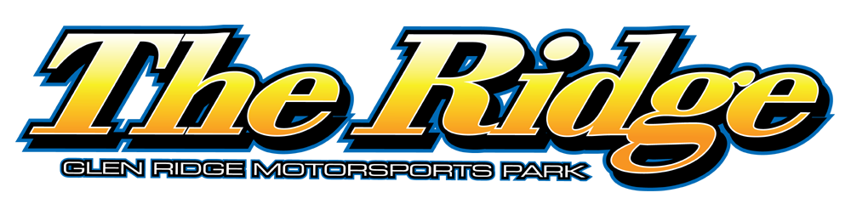

2024 PRO-STOCK SPECS

The Pro Stock division at The Ridge will follow the 2024 DIRTcar rule book with the following exceptions:

1) Tires – Hoosier D60

2) Fuel – VP Race Fuels is the preferred fuel at the Glen Ridge Motorsports Park. Or Pump Fuel. No oxygenated fuel.

3) Fire Suppression Bottle – Not mandatory for weekly competition, BUT highly recommended at The Ridge – no weight break for teams utilizing this option but will be mandatory for the Super Dirt Series event.

DIRTcar Pro Stock rules, subject to adjustment by The Ridge tech officials at any time.

