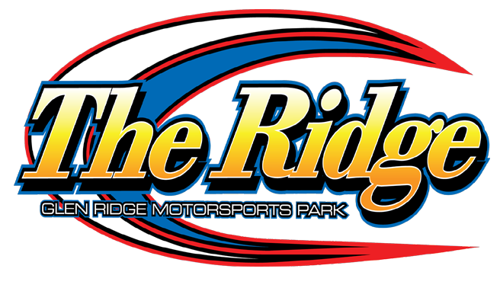

2024 LIMITED SPORTSMAN SPECS

Rev. boxes are mandatory set at no more than 6000 RPM

LIMITED SPORTSMAN CLASS ELIGIBILITY REQUIREMENTS:
1. Any driver who has competed and qualified for a Big Block Modified event is not eligible for this division.
2. Any driver who has recorded a Sportsman or a Modified win will NOT be eligible for this division.
3. Any driver who competes in the Sportsman division at another track which also has a limited class is not eligible to compete in the limited division.
RULES:
1. If a Driver reaches a three (3) win total in the season, that driver will be required to move up to the Sportsman Division the following season. Management reserves the right to request any driver move up to the Sportsman division, at any time, at their discretion. The champion will automatically be moved up to the Sportsman division the following season.
2. All safety and technical rules are outlined in the Sportsman section of the DIRTcar Rule Book Northeast Section. The ignition amplifier box (“rev box”) and coil must be mounted under the hood and on a panel behind the air filter shielded from heat (out of the driver’s reach) for ease of inspection. The black wire must be grounded to the motor. If using a DIRT MSD box, you must get power from a 2 terminal, single pole switch that has no other items attached to it. MSD wire harness must be 100% as sent from factory with no splices. Ground wire must go directly to back of intake manifold. Automatic disqualification if altered in any way. When the hood is removed the “rev box” must be clearly visible and not covered. The car must be fitted with one (1) unaltered approved MSD/DIRTcar RPM (rev) limiting box, maximum 6000 RPM with adjustment if necessary. The box and the chip must remain operable and in working condition, prior to, during and after all racing events. The MSD 8727CT will be the only MSD/DIRTcar RPM (rev) limiting box permitted for competition.
EXHAUST – Maximum 3" exhaust pipes are allowed throughout the exhaust system. No stainless allowed anywhere in exhaust system.
4. For engine rules, refer to the 2024 DirtCAR Northeast Section Rule Book.
5. WHEEL COVERS – No wheel covers held on by dzeus buttons or similar type fasteners will be permitted. Only wheel covers that are bolted to the beadlock or are a part of the beadlock will be permitted. Foam inserts will be permitted. No plastic wheel covers are allowed. *
Rules Are Subject To Change*

